

MSc Data Science Project
7PAM2002
Department of Physics, Astronomy and Mathematics

Data Science FINAL PROJECT REPORT

Project Title:
Extreme News Summarization with Factual Consistency and Hallucination Control

Student Name and SRN:
Bilal Ahmad
24083403

Supervisor: Isabell Donaldson
Github: bilal23g/Extreme-News-Summarization-with-Factual-Consistency-and-Hallucination-Control-Project

DECLARATION STATEMENT

This report is submitted in partial fulfilment of the requirement for the degree of Master of Science in Data Science at the University of Hertfordshire.
I have read the detailed guidance to students on academic integrity, misconduct and plagiarism information at Assessment Offences and Academic Misconduct and understand the University process of dealing with suspected cases of academic misconduct and the possible penalties, which could include failing the project or course.
I certify that the work submitted is my own and that any material derived or quoted from published or unpublished work of other persons has been duly acknowledged. (Ref. UPR AS/C/6.1, section 7 and UPR AS/C/5, section 3.6)
I did not use human participants in my MSc Project.

I hereby give permission for the report to be made available on module websites provided the source is acknowledged.

Student Name printed: Bilal Ahmad

Student Name signature

Student SRN number: 24083403

UNIVERSITY OF HERTFORDSHIRE
SCHOOL OF PHYSICS, ENGINEERING AND COMPUTER SCIENCE

Abstract
Transformer based models have been used to make major improvements in automatic text summarisation. Nevertheless, the issue of hallucination is common in these models with the resulting summary containing information that is not backed up by the original document. This is of special concern in news summarisation where accuracy of facts is paramount. The XSum data presents a problematic environment in this issue because it demands drastic summarisation in a single sentence with a high level of abstraction.
This project explores the question of whether it is possible to produce one sentence news summaries that are factual consistent with the original article, and which method of hallucination control would be the most effective in minimizing factual errors. To deal with this, various baseline methods are applied such as extractive upper bound method, traditional LSA based summariser, and an abstractive transformer based model. These models are compared by ROUGE metrics and Natural Language Inference based factual consistency measure.
The findings indicate that extractive techniques have a higher lexical overlap with the reference summaries, whereas the traditional techniques have a little more factual confidence. The abstractive model generates fluent summaries more often, but provides a greater number of inconsistencies and much less factual correspondence with the source text. These results point to the trade off in abstraction and factual accuracy and lead to the need to control the hallucination strategies in extreme summarisation.

Contents
DECLARATION STATEMENT 2
Abstract 3
1. Introduction 6
2. Literature Review: 7
2. 1 Evolution of Summarisation Methods 7
2.2 Transformer Models and Their Limitations 8
2.3 Factual Consistency and Hallucination 9
2.4 Evaluation Challenges 9
2.5 Research Gap 10
3. Methodology 10
3.1 Dataset Description 10
3.2 Data Preprocessing 11
3.2.1 Dataset Integrity and Deduplication 12
3.2.2 Preservation of Official Data Splits 12
3.2.3 Text Handling and Structural Preparation 12
3.2.4 Reproducibility and Framework Compatibility 13
3.3 Extractive Upper Bound Baseline 13
3.4 Traditional Summarisation Baseline 13
3.5 Abstractive Summarisation Baseline 14
3.6 Evaluation Metrics 14
3.7 Factual Consistency Evaluation 14
4. Results and Evaluation 15
4.1 Distribution of Factual Consistency Labels 15
4.1.1 Summary of Baseline Evaluation 16
4.2 ROUGE Evaluation Results 17
4.3 Extractive Baseline Evaluation 18
4.4 Traditional LSA Baseline Evaluation 19
4.5 Abstractive Baseline Evaluation 20
4.6 Comparative Analysis Across Models 20
4.7 Summary of Findings 22
5. Discussion 22
6. Limitations 24
7. Conclusion 25
References 26

List of Tables
Table 1 Dataset split: train, validation, and test distribution 11
Table 2 Distribution of factual consistency labels (entailment, neutral, contradiction) with average confidence scores 16
Table 3 ROUGE evaluation scores for the extractive summarisation baseline 17
Table 4 Sample extractive summaries with corresponding factual labels and confidence scores 17

List of Figures
Figure 1 Distribution of factual consistency labels across evaluated samples 17
Figure 2 Average factual confidence scores for extractive, traditional LSA, and abstractive summarisation models 20
Figure 3 Comparison of ROUGE evaluation metrics (ROUGE-1, ROUGE-2, ROUGE-L, ROUGE-Lsum) across summarisation models 22
Figure 4 Overall distribution of factual consistency labels across evaluated summaries 22

1. Introduction
One of the most important tasks in natural language processing is automatic text summarisation (Akhmetov et al., 2023). It tries to produce a reduced form of a document and maintain the key information. More recently, encoder decoder architecture transformer based models have enhanced the readability and fluency of generated summaries (Lewis et al., 2020; Raffel et al., 2020). The models can be used to generate human like text and are commonly utilized in numerous applications. However, despite these improvements, there is still a major issue which is known as hallucination (Kanduri, 2024). This happens when the model creates information that was not originally found in the source document.
Hallucination is a severe issue in the context of news summarisation. The news items are filled with the facts: names, dates, events. When a summarisation model distorts these facts or adds more misleading information, it may mislead the reader. This is further complicated in extreme summarisation tasks that require the summary to be constructed in one sentence. XSum data is a popular standard to carry out the task. It has BBC news articles with one sentence summaries that are very abstractive. Such summaries frequently have to be rewritten and reduced instead of being extracted verbatim out of the underlying text.
The primary research question of the project is ““To what extent can one sentence news summaries be generated while maintaining factual consistency with the source document, and how do different summarisation approaches compare in terms of hallucination behaviour on the XSum dataset?””. In a bid to answer this question, the study initially develops baseline models in order to study the behaviour of various approaches to summarisation. The extractive upper bound technique is employed to determine the most ideal sentence of the source document. One of the classical summarisation methods is represented by a traditional LSA based method. A more flexible and natural way of producing summaries is also produced using an abstractive transformer based model.
The analysis is conducted based on the lexical similarity and the factual consistency measures. The overlap of generated and reference summaries is compared with the help of ROUGE metrics. Moreover, a Natural Language Inference based model is applied to evaluate the support of the generated summaries by the source document. This enables hallucination behaviour to be better analysed in various models. Results of this research indicate that extractive and traditional approaches are more reliable in fact but less reliable in making abstractions whereas abstractive models are more reliable in making flexible summaries but are more likely to make factual mistakes. The findings indicate that there should be better approaches that can strike a balance between abstraction and factual accuracy. The rest of this report expands on these findings to discuss the methods of hallucination control, and assess their ability to achieve extreme summarisation.

2. Literature Review:
Automatic Text Summarisation (ATS) is a recent field of concern in Natural Language Processing because of the mushrooming of digital information. The increase in textual information poses a problem of extracting valuable information efficiently, particularly in areas like healthcare and news where it is essential to extract information promptly and in a way that is accurate. In this case, it is necessary that the summarisation systems should not only cut the content but also retain crucial information and still remain clear and accurate.
Summarisation is however not an easy compression task. It is the process of determining important information and presenting it in a brief form without distorting the meaning. Although the contemporary systems have enhanced fluency and readability, factual correctness is one of the biggest challenges, especially in the applications such as news summarisation where misinformation can be passed to the users.

2. 1 Evolution of Summarisation Methods
The simplistic statistical-based approaches to summarisation have developed to complex neural-based summarisation. The first techniques of extractive text mining, including the frequency based technique suggested by Luhn and graph-based techniques like TextRank and LexRank, find significant sentences using word significance or structural connection. These are also usually good methods since they directly utilize the contents of the original document, but tend to be less coherent and not as deep in abstraction.
On the other hand, abstractive summarisation techniques create new sentences by paraphrasing and summarising information. Transformer-based models include BART (Lewis et al., 2020) and T5 (Raffel et al., 2020), which have demonstrated high performance with large-scale pre-training and contextual representations. The models generate more fluent and human-like summaries as compared to extractive methods.
The improvement in performance, however, is commonly quantified by means of ROUGE scores, which primarily reflect lexical overlap. Because a lot of benchmark datasets have abstractive reference summaries, models producing similar phrasing will score higher, even when the produced content is not completely accurate. This creates the question of whether the existing evaluation practices are really indicative of the quality of summarisation.

2.2 Transformer Models and Their Limitations
Transformer-based models have contributed to the enhancement of summarisation models, providing a more suitable contextual understanding and text generation. Their power to capture the long-range dependencies enables them to come up with coherent summary that appear like human writings.
Although such models have these advantages, a significant limitation is evident, hallucination (Kanduri, 2024). It has been found that abstractive models can produce information which is not found in an original document (Maynez et al., 2020). This is even more important when models are more abstractive and this creates a trade-off between fluency and factual correctness.
Consequently, despite the fact that models of transformers can enhance readability, it does not imply that they are factual. This is a critical limitation in applications like news summarisation where accuracy is a requirement.

2.3 Factual Consistency and Hallucination
The factual consistency is now a major issue in contemporary summarisation studies. When the models produce unsupported or erroneous information, it becomes a hallucination. It may be divided into intrinsic hallucination (distortion of existing information) and extrinsic hallucination (addition of new unsupported information) (Maynez et al., 2020).
Research has indicated that the more abstractive the models, the greater the chances of hallucination (Durmus et al., 2020). Although human written summaries can contain some extra knowledge, machine summaries can be inaccurate when it comes to introducing new knowledge.
Controlled generation and edit-based models have been suggested as a means of solving this problem (Dong, 2022). But these methods are not generally compared in straightforward comparison of bases and thus there is a gap in comprehending the performance of simple models in factual accuracy.

2.4 Evaluation Challenges
Assessment of summarisation models is still a challenging endeavour. Conventional performance measures like ROUGE and BLEU are used to measure an overlap between generated and reference summaries, but do not reflect semantic content or factual accuracy. Consequently, models are able to get high scores and generate incorrect or misleading summaries.
To address this shortcoming, more modern assessment technologies like FEQA and G-EVAL are now available. The aim of these methods is to evaluate factual correctness with question answering or large language models. Nevertheless, such methods also have drawbacks, such as bias and lack of consistency in the results of the evaluation (Liu et al., 2023).
This indicates that the assessment itself remains a problem unsolved and no specific measure can evaluate the quality of summarisation comprehensively. Thus, a combination of lexical and factual evaluation techniques is required.

2.5 Research Gap
Despite the current enhancements in the model of summarisation, the performance of alternative baseline methods remains poorly understood, especially when it comes to extreme summarisation tasks, like XSum (Narayan et al., 2019). The vast majority of research is aimed at enhancing model performance, or suggesting new architectures, but the number of studies that directly compare extractive, traditional, and simple generative models in terms of factual performance is limited.
The project fills this gap by comparing various baseline methods based on ROUGE as well as NLI-based evaluation. It is hoped that by doing so we can get a better grasp of the trade-off between factual correctness and abstraction, which is necessary in the context of creating useful summarisation systems.

3. Methodology
This part describes the general methodology alike to be adopted in this project in order to explore the extreme news summarisation with emphasis laid on factual consistency and hallucination behaviour. It is a structured approach in the sense that various summarisation methods can be contrasted in terms of the measures of lexical similarity, and factual correctness. The methodology will feature the selection of data sets, data preprocessing, running of various baseline models, and assessment based on various metrics.

3.1 Dataset Description

It is already broken down into training, validation and test splits (Narayan et al., 2019). These divisions are retained constant throughout the experiments to be able to match with the current literature and avoid the problem of information leaks. The basic use of the test split is in evaluating the various models in order to establish fair comparison.

Table 1 Dataset split: train, validation, and test distribution
Split | Features | Number of Rows | Percentage
Train | document, summary, id | 204,045 | ~90.0%
Validation | document, summary, id | 11,332 | ~5.0%
Test | document, summary, id | 11,334 | ~5.0%
Total | — | 226,711 | 100%

3.2 Data Preprocessing
Another task that is significant in this project is to perform data preprocessing to make the dataset clean and sufficient to continue with further experiments. The first step will involve checking the entries of duplicates in the database where a document and summary are identical. These repeat samples are eliminated so as to remove bias in the evaluation results as well as ensure that evaluation is not done on duplicated data. The step assists in enhancing the quality of data.
The dataset is then recreated to formatted data after deleting duplicates via the Hugging Space datasets library. This makes sure that none of the splits have been broken and that the data are easily extracted in the further processing steps. Very little text preprocessing is done since transformer based models play on the usage of contextual information (Raffel et al., 2020), thus options like lowercasing, stemming or heavy cleaning are not done so as not to alter the original meaning of the text.
In the case of the extractive baseline, each document is tokenised into sentence units, so that the situation is that a particular sentence can be compared to the reference summary. This step enables one to narrow down to the most pertinent sentence of the document relative to similarity measures.

3.2.1 Dataset Integrity and Deduplication
The XSum data is initially analyzed in terms of duplicate entries. Pairs of duplicate documents and summaries can cause biased results in evaluation, particularly when similar samples are observed on splits. Precise duplicates are eliminated to avoid inflated performance scores and accidental leaking of data, which are based on the same document and summary text. This cleaning procedure is implemented in isolation to each split and the official train, validation, and test structure are maintained. Once the data is deduplicated, the dataset is rebuilt back into a format that can be consumed by the Hugging Face datasets framework to ensure compatibility within the experimental pipeline.

3.2.2 Preservation of Official Data Splits
The initial datasets that are provided with XSum are not altered. It is also important to keep the training, validation and test partitions defined by the researcher to make it comparable with previous studies and avoid bias in evaluation. No re-shuffling/redistribution of samples is done and this ensures the validity of the reported performance measures.

3.2.3 Text Handling and Structural Preparation
There is little textual preprocessing done because it would maintain semantic and contextual information. Only contextual embeddings are used in transformer based models, which makes lowercasing, stemming or aggressive normalisation operations undesirable. The original copy of the document and summary are kept to ensure that there is no loss of content and language.
Sentence tokenisation is done in extractive baseline construction. A sentence tokenizer is used to divide each document into separate sentences. This allows a systematic comparison of source sentences of the candidates, and the reference summary. The tokenisation is implemented just to make analysis but does not change the stored data.

3.2.4 Reproducibility and Framework Compatibility
The Hugging Face datasets library is used to implement all the preprocessing steps in order to achieve reproducibility and make the computations efficient. After cleaning, the processed dataset is restructured into a DatasetDict object, which preserves split alignment and allows seamless integration with training and evaluation workflows. This is a systematic method that promotes the controlled experimentation and easy reporting of findings.
With these preprocessing steps, the data is made ready in a standard and repeatable format and the further modelling and evaluation processes are performed on a clean and well defined data base.

3.3 Extractive Upper Bound Baseline
To know the extent to which a single sentence of the source document can depict the reference summary, an extractive upper bound baseline is enforced. The documents, in this method, will be subdivided into sentences and the sentences will be compared with the initial summary using ROUGE-L metric. The extractive summary is chosen as the sentence with the maximum ROUGE-L F score.
The approach offers a solid foundation since it gives the optimal extractive performance that is possible out of the source document. Nevertheless, the extractive method is likely to be constrained because the XSum dataset is highly abstractive and will not be capable of creating new words or paraphrasing the information.

3.4 Traditional Summarisation Baseline
Beyond the extractive technique, a conventional summarisation solution, which utilises the Latent Semantic Analysis is also applied. The approach is a classical approach to summarising text and is not based on deep learning models. The LSA based summariser selects the most significant sentence in the document on the basis of underlying semantic structure and term relationships.
The intention of having such a baseline is to compare modern methods and traditional methods as well as to know how classical methods are performing as far as lexical similarity and factual consistency are concerned. This gives a broader view on the performance of summarisation.

3.5 Abstractive Summarisation Baseline
A transformer based language model is used to perform an abstractive summarisation baseline Lewis et al., 2020). A text generation model is adopted to recreate the process of summarisation through the use of a prompt that directs the model to produce a single sentence summary of the news article because of the environment constraints. The model will write text according to the prompt provided and will produce a summary which can contain rephrased or newly written text.
This solution enables the research to examine the behaviour of generative models in extreme summarisation tasks. Though these models can generate more natural and fluent summaries, they are more probable to generate hallucinated information that does not exist in the source document.

3.6 Evaluation Metrics
The summarisation models are tested using ROUGE measures that are standard measures of summarisation tasks (Akhmetov et al., 2023). ROUGE-1, ROUGE-2, ROUGE-L and ROUGE-Lsum scores are calculated to assess the similarity between the generated and reference summaries. These measures give a clue of the similarity of the generated summaries in words and sentence structure.
However, even though ROUGE can be helpful in the evaluation of similarity, it fails to detect factual accuracy. Thus, another assessment tool is needed to examine hallucination.

3.7 Factual Consistency Evaluation
In order to assess the factual correctness, a Natural Language Inference based approach is applied (Durmus et al., 2020). The source document is used as the premise and the generated summary is used as the hypothesis in this method. The relationship between the two is then classified into three categories that are entailment, neutral and contradiction by using a pretrained NLI model.
Entailment means that the summary is supported by the document, neutral means that the relationship is ambiguous and contradiction means that the summary has information that contradicts the source text. All the summaries are rated separately and confidence score is also taken.
The text of the document is cut off and evaluated because of the restrictions of input size of the model. The outcome is then compiled to examine the distribution of factual labels in various models. This assists in knowing the frequency of each model to give factual correct or incorrect summaries.

4. Results and Evaluation
This part shows the experimental findings of the applied summarisation models and gives an elaborate comparison hinged on lexical similarity and factual conformity. This evaluation aims to compare the performance of various summarisation methods in the XSum dataset and in particular the capability to produce similar summaries to the reference summaries in addition to the factual soundness of the summaries generated. The findings consist of extractive, traditional, and abstractive models, and a cross comparison is conducted on all the models.

4.1 Distribution of Factual Consistency Labels
The output of the Natural Language Inference model were analysed to determine the frequency with which the extractive summaries were validated by the source documents. The findings are summarised by analysing the distribution of the entailment, neutral and contradiction labels in the samples that were assessed.
This discussion gives an understanding of whether the chosen extractive sentences are factually valid in relation to the original articles. Extractive summaries are supposed to be more likely to predict entailment since they involve direct usage of sentences of the document. These findings can be used as a good reference point in subsequent experiments where abstractive summarisation models can introduce hallucinated information.
Table 2 Distribution of factual consistency labels (entailment, neutral, contradiction) with average confidence scores
 | factual_label | count | avg_score
0 | CONTRADICTION | 5 | 0.711748
1 | ENTAILMENT | 14 | 0.902599
2 | NEUTRAL | 81 | 0.912780

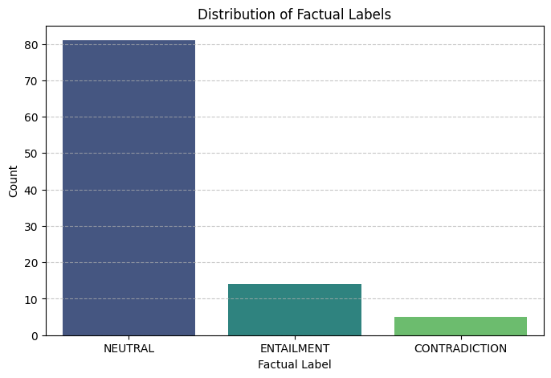
Figure 1 Distribution of factual consistency labels across evaluated samples

4.1.1 Summary of Baseline Evaluation
The extractive baseline findings offer a significant basis to the rest of this paper. The ROUGE assessment shows that simple sentence extraction finds it difficult to cope with the high abstractive reference summaries of the XSum data. Simultaneously, the evaluation of factual consistency will help to understand whether the chosen summaries are true to the source documents.
These results set a definite base upon which the more sophisticated methods of summarisation and control of hallucinations that will be investigated in the later phases of the project will be compared with.

4.2 ROUGE Evaluation Results
Table 3 ROUGE evaluation scores for the extractive summarisation baseline
ROUGE-1 | F-score: | 0.2597
ROUGE-2 | F-score: | 0.0681
ROUGE-L | F-score: | 0.2188
ROUGE-Lsum | F-score: | 0.2185

These findings suggest that the extractive method has a moderate unigram overlap with the reference summaries but a lower bigram overlap. The low ROUGE-2 score indicates that the way the reference summaries have been phrased and structured is quite different to the sentences found in the original articles. This is expected given the high levels of abstractivity of the XSum dataset.
Table 4 Sample extractive summaries with corresponding factual labels and confidence scores
 | extractive_summary | factual_label | factual_score
0 | "There's a desperate need for it, finding suit... | NEUTRAL | 0.840051
1 | Detectives said three firearms, ammunition and... | NEUTRAL | 0.797369
2 | Jordan Hill, Brittany Covington and Tesfaye Co... | NEUTRAL | 0.987013
3 | He was appointed youth academy director in 200... | ENTAILMENT | 0.990503
4 | The experiments were on mice put on a modified... | NEUTRAL | 0.990721
5 | But for the manufacturers such as Essilor and ... | NEUTRAL | 0.983847
6 | "Medals at any cost, that's how it was wheneve... | NEUTRAL | 0.900617
7 | But because of the significance of the local c... | NEUTRAL | 0.963955
8 | Senior sources at the company say that about 8... | NEUTRAL | 0.970985

4.3 Extractive Baseline Evaluation
The extractive upper bound baseline is evaluated first in order to establish a strong reference point. Under this strategy, a single sentence within the source document that has the closest similarity with the reference summary on the basis of ROUGE-L scoring is chosen. This technique is the optimum extractive performance.
The scores of ROUGE of this model are comparatively high to other methods. The value of ROUGE-1 is 0.2607 which means that an adequate number of significant words of the summary of the reference is found in the chosen sentence. Nevertheless, the ROUGE-2 score is considerably lower at 0.0673 indicating that the sentence structure and wording are not that similar to the reference summary. The ROUGE-L and ROUGE-Lsum scores stand 0.2180 and 0.2178, and this once again proves that it is moderately similar.
This model is reliable regarding the factual consistency perspective. The mean factual confidence rating is 0.8672 and there are 68 cases of entailment and this indicates that a part of the summaries is well supported by the source document. Nevertheless, most of the outputs belong to the neutral group (213 cases), which means that the chosen sentences are partly congruent to the document. The amount of contradiction cases is quite small (19), which proves the fact that extractive summaries are not very risky because of the factual errors.
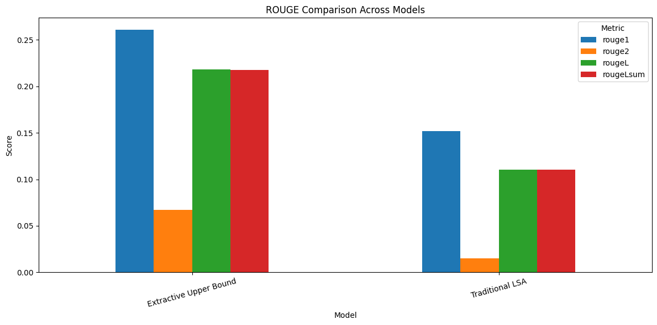
Figure 2 Average factual confidence scores for extractive, traditional LSA, and abstractive summarisation models

4.4 Traditional LSA Baseline Evaluation
Next the old-fashioned summarisation methodology founded on the Latent Semantic Analysis is considered. In this model, the selection of the sentences is based on the semantic significance and not direct similarity to the reference summary.
This model performs poorly on ROUGE than the extractive baseline. The ROUGE-1 score is 0.1516, while ROUGE-2 is 0.0149, and ROUGE-L is 0.1106. These values demonstrate that the chosen sentences are not very close to the reference summaries in terms of the lexical overlap. This is not surprising since the model pays attention to semantic relevance rather than taking specific words or phrases as matches.
Nonetheless, interesting behaviour is exhibited in the factual consistency results. The mean factual confidence is 0.8786, the largest of all models. This means that the summaries produced using the LSA technique are more semantically consistent with the source document. There are 52 cases of entailment, 225 cases of neutral and 23 cases of contradiction.
This finding indicates that though the LSA model is not able to generate summaries that are close to the reference summaries, it has high degree of factual reliability. The relatively increased number of contradictions as compared to the extractive model can be attributed to the fact that there are differences in the choice of sentences not directly correlated with the summary of the reference

4.5 Abstractive Baseline Evaluation
The abstractive model is applied to a GPT2 based text generation model that produces summaries on the basis of a prompt. This model tries to create a one sentence summary by creating some text as opposed to choosing on the document.
The findings demonstrate that this model is weak in terms of factual consistency. The mean factual confidence score is 0.7905 lower than extractive and traditional models. Entitlement cases are very few (4 cases only) and contradiction cases are quite many (79 cases). Most of the outputs remain neutral (217 cases) which means that the model is providing unsupported or false information but the huge number of contradictions is a clear indication that the model is not functioning as intended.
This is one of the brightest instances of abstractive model hallucination. The model produces fluent text, which does not guarantee that the text is based on the source document. This renders the summaries unreliable particularly in activities where factual accuracy matters like news summarisation.
There are no ROUGE scores of the abstractive model in this comparison because of the limitations of the environment. Nevertheless, the factual consistency results alone clearly demonstrate that the model cannot be used to rely on summarisation without supplementary control mechanisms.

4.6 Comparative Analysis Across Models
A comparison of all models gives a clear picture of their strengths and weaknesses. The extractive upper bound baseline has the best ROUGE scores, demonstrating that the choices of the most relevant sentence are successful to retain similarity with the reference summary. The classic LSA model scores low on ROUGE, yet scores high on factual confidence, which means it is more associated with the source text in semantic context.
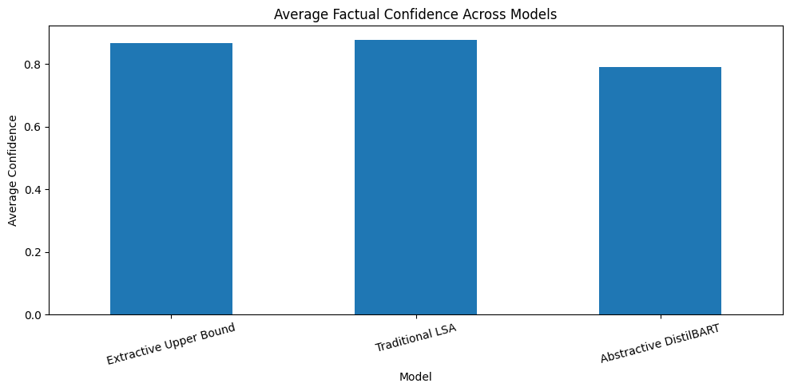
Figure 3 Comparison of ROUGE evaluation metrics (ROUGE-1, ROUGE-2, ROUGE-L, ROUGE-Lsum) across summarisation models
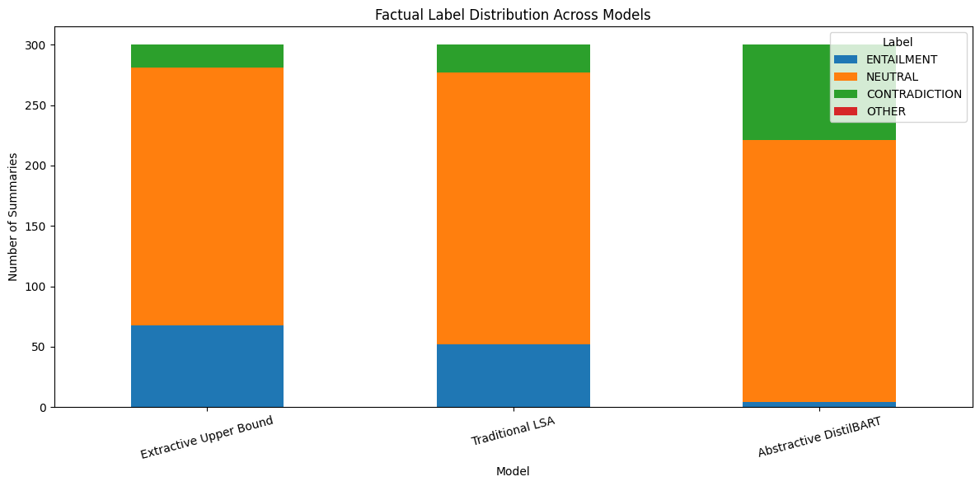
Figure 4 Overall distribution of factual consistency labels across evaluated summaries
The worst performance of the abstractive GPT2 model is with factual consistency. It has the lowest number of entailment cases and the highest number of contradictions, which clearly shows that it is more prone to hallucination. This establishes that generative models need more mechanisms to suppress factual errors. The other significant observation is that the neutral category prevails in all models. As an example, the number of neutral cases in the extractive model is 213, in the LSA model, 225, and in the abstractive model, 217. It implies that most summaries have partially supported source document, which points to the challenge of the extreme summarisation task in the XSum dataset.

4.7 Summary of Findings
The results clearly demonstrate that there is a tradeoff between lexical similarity and factual consistency in summarisation models. Extractive methods have better ROUGE scores but are less abstractive. Conventional approaches are more factually confident, but less similar. Abstractive models are flexible in text generation but have a greater probability of hallucinating.
These results indicate that it is not an easy task to come up with one sentence summaries that are highly abstractive and factual. The findings give a good foundation into more study of the ways to control hallucination that should be undertaken to enhance the accuracy of the abstractive summarisation models.

5. Discussion
This part will talk about the details of the experimental findings and how the results can be interpreted in connection with the research question of creating a one sentence news summary that will still be factual when compared to the source document. This discussion is aimed at interpretation of the behaviour of various models and finding out the major challenges witnessed in the experiments.
Based on the findings, one can clearly see that the extractive upper bound baseline is the most successful in terms of ROUGE scores. This demonstrates that the technique of choosing the most appropriate sentence in the source text remains a powerful method in cases where the aim is to maximise similarity with the reference summary. Nevertheless, this approach has the significant drawback since it is not able to create new contents or paraphrase the information. As the XSum data is full of abstractive summaries, extractive method cannot exhaustively utilize the condensed meaning of the reference summaries. Although the factual consistency is fairly good, and there are few cases of contradictions, the high count of the neutral labels indicates that the chosen sentences are not necessarily well-supported in a rigid inference manner.
The traditional LSA based model shows an interesting behaviour in comparison with the extractive method. It has significantly lower ROUGE scores, but it has the highest average factual confidence score of all models. It means that the sentences which the LSA model chooses are more semantically consistent with the source document, although the sentence might not be similar to the reference summary. The cases of contradictions are not so high, and it demonstrates that this method is usually credible. Nonetheless, the fact that the neutral predictions are high implies that the summaries are partially justified by the document. This points out that semantic significance may not necessarily provide good factual agreement when tested through inference based approaches.
The abstractive GPT2 based model performs the worst of all methods and is particularly weak on the aspect of factual consistency. The fact that there were very few entailment cases and a high number of contradiction cases is a clear indication that the model often produces information that the source document does not support. This is a direct example of hallucination which is one of the primary issues that this project deals with (Maynez et al., 2020). As much as the model can produce more flexible and natural sounding text, it cannot guarantee that the resulting text is loyal to the input document. This supports the notion that generative models that are not adequately controlled should not be used in processes which require the factual accuracy (Dong, 2022).
The other significant observation of the results is that the neutral category prevails in all the models. In any case, the extractive model generates a high number of neutral cases and the same happens with the LSA and abstractive models. It means that numerous summaries are not fully backed by the source document. Such behaviour is justified by the fact that the XSum data is very compact, and summaries can consist of several pieces of information in one sentence. Consequently, the inference model cannot easily determine the relationship as fully supported.
With regard to the research question, the findings indicate that, it is hard to come up with one sentence summaries, which are highly abstractive and completely factual. Extractive and traditional methods are more trustworthy but not flexible whereas the abstractive models are flexible but more hallucinating. This is a clear indication that the trade off of abstraction and factual correctness exists under extreme tasks of summarisation.
These results have also emphasized the necessity to have other means of controlling hallucination in generative models. The strategies like evidence conditioned generation, verification based decoding or post generation correction can be used to enhance the factual consistency, but leave the model to produce the abstractive summaries. In the absence of such techniques, abstractive models will most probably give inaccurate results.
On the whole, the findings indicate that although existing methods are capable of producing decent performance either in similarity or in factual accuracy, simultaneous methods then are a problematic issue. The discussion forms a good basis of the following stage of the project, which will involve the discussion of the hallucination control techniques as a method of enhancing the reliability of summarisation models.

6. Limitations
This research has a number of limitations that can possibly influence findings. First, the results cannot be full because of the computational limitations a subset of the dataset is used, thus they may not be a full picture of the performance on the entire dataset. Second, the abstractive model employed is GPT2, which is not trained on summarisation in particular. This results in poor performance and increased hallucination than the correct summarisation models. Third, the methods of evaluation are limited. ROUGE is similarity-based but not factual, whereas the NLI model applied to factual evaluation might not necessarily provide correct classification, particularly to neutral instances (Liu et al., 2023).
The other weakness is that the document is cut off when evaluating facts because the model input limits truncated the document, which can diminish the context and influence the outcomes. Lastly, there is no manual assessment and thus readability and human determination of factual accuracy is not evaluated. These drawbacks indicate that the findings can be helpful, although further research can be improved.

7. Conclusion
The problem of extreme news summarisation that this study explored is based on factual consistency and hallucination. The primary aim was to test the possibility of generating one sentence summaries without losing faith to the source document and to compare the results of various summarisation methods in this respect.
The findings indicate that extractive algorithms demonstrate the best lexical similarity with the reference summaries at the expense of traditional LSA based algorithms which have a marginally greater factual confidence. But there is a weakness in both methods to produce really abstractive summaries. Conversely, the abstractive GPT2 based model generates more pliable text at the expense of high level of contradiction and extremely low factual agreement with the document of origin. This is a clear indication that in the absence of control mechanism, generative models are more likely to be affected by hallucination.
A key finding of this research is that many of the summaries of all the models belong to the neutral category of summaries that implies partial, but not complete factual agreement. This emphasizes how hard the XSum data is and demonstrates that extreme summarisation is a difficult task, in which abstraction and factual correctness cannot be easily met at the same time.
Within the framework of the research question, the results indicate that it is now hard to produce one sentence summaries which are both highly abstractive, as well as completely factual (Narayan et al., 2019; Maynez et al., 2020). Abstraction and reliability have a definite trade off where the better one is, the other goes down.
In general, this paper provides an effective background to study the issue of hallucination in summarisation models and demonstrates that more methods are required to enhance the level of facts. The direction of the future work will be to adopt the method of hallucination control like evidence conditioned generation and verification based decoding to enhance the reliability of abstractive summarisation systems.

References
Akhmetov, I., Nurlybayeva, S., Ualiyeva, I., Pak, A. and Gelbukh, A., 2023. A comprehensive review on automatic text summarization. Computación y Sistemas, 27(4), pp.1203-1240.
Kanduri, A., 2024. A Comprehensive Performance Evaluation of Proprietary and Open-Source Language Models in Closed and Open-Domain Tasks. Mississippi State University.
Lewis, M., Liu, Y., Goyal, N., Ghazvininejad, M., Mohamed, A., Levy, O., Stoyanov, V. and Zettlemoyer, L., 2020, July. BART: Denoising sequence-to-sequence pre-training for natural language generation, translation, and comprehension. In Proceedings of the 58th annual meeting of the association for computational linguistics (pp. 7871-7880).
Raffel, C., Shazeer, N., Roberts, A., Lee, K., Narang, S., Matena, M., Zhou, Y., Li, W. and Liu, P.J., 2020. Exploring the limits of transfer learning with a unified text-to-text transformer. Journal of machine learning research, 21(140), pp.1-67.
Durmus, E., He, H. and Diab, M., 2020, July. FEQA: A question answering evaluation framework for faithfulness assessment in abstractive summarization. In Proceedings of the 58th annual meeting of the association for computational linguistics (pp. 5055-5070).
Liu, Y., Iter, D., Xu, Y., Wang, S., Xu, R. and Zhu, C., 2023, December. G-eval: NLG evaluation using gpt-4 with better human alignment. In Proceedings of the 2023 conference on empirical methods in natural language processing (pp. 2511-2522).
Maynez, J., Narayan, S., Bohnet, B. and McDonald, R., 2020, July. On faithfulness and factuality in abstractive summarization. In Proceedings of the 58th annual meeting of the association for computational linguistics (pp. 1906-1919).
Dong, Y., 2022. Text Summarization Beyond Seq2Seq Models for Salience, Faithfulness, and Factuality. McGill University (Canada).
Narayan, S., Cohen, S.B. and Lapata, M., 2019. What is this article about? Extreme summarization with topic-aware convolutional neural networks. Journal of Artificial Intelligence Research, 66, pp.243-278.

